Vehicle movements in and out of Donyatt and as recorded on the speed indicator devices.
Donyatt Parish Council owns two Speed Indicator Devices (SID), which are located on the A358 at the entrance to the village from Peasmarsh (Opposite Knights Electrical) and at Donyatt Hill.
Each SID collects data of all vehicles passing its location in both directions. This data can be downloaded into a data base and information extracted in different formats to show; number of vehicles passing, Speed ranges, timings, etc.
This data shows the period between the 14th July 2026 to 6th August 2026.
A358 PEASMARSH – CHARD TO AND FROM DONYATT
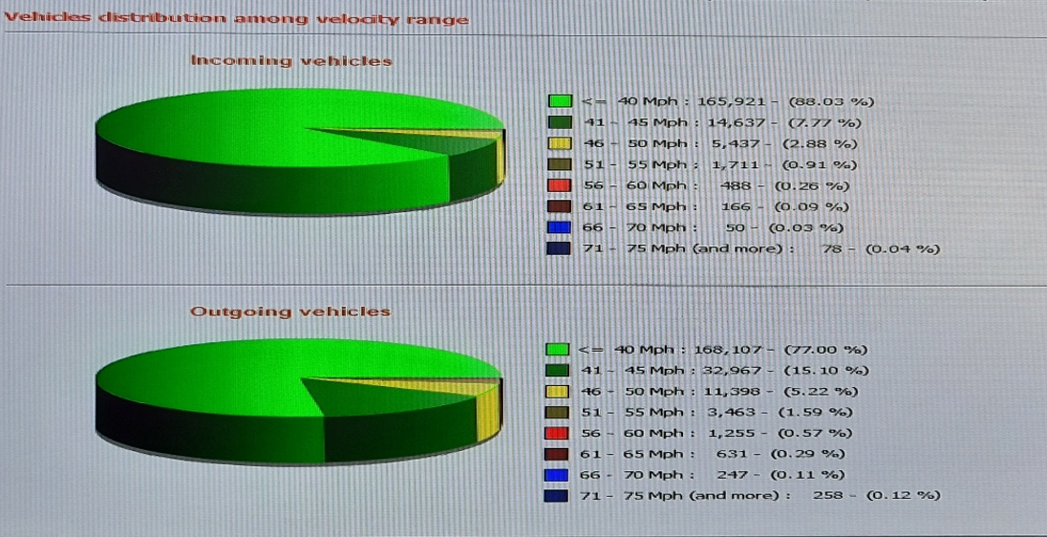
DONYATT HILL TO AND FROM A303
Vehicles entering village 188488 over the set period. Data shows 165921 (88.03%) were under 40Mph.
Vehicles leaving village: 218326 over the set period. Data shows 168107 (77%) were under 40Mph.
The Green on the chart represents the number of vehicles entering and leaving the village at 40 Mph and below.

